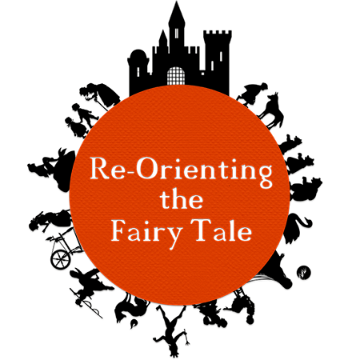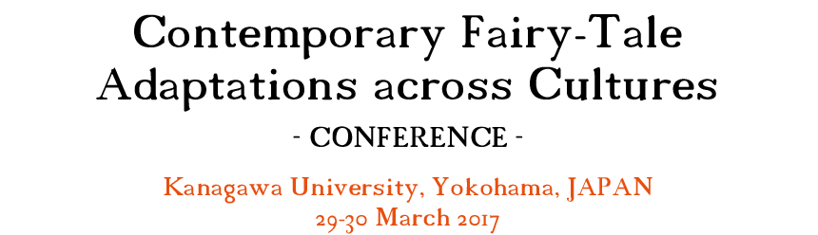
Registration Form (one per person)

Please fill in this form and send it back to: fairytale.yokohama@gmail.com
* There will be a maximum of 60 participants including presenters (first come, first served).
Registration deadlines:
1 December 2016 (If you wish to book the hotel at the conference rate; no deposit required)
1 March 2017 (If you wish to make your own arrangements for accommodation)
Registration fees:
5,000 yen for two days (including refreshments, lunches & conference reception on the first day) to be paid in cash at venue on the first day (no credit or debit cards)
- Personal Information
Title: First Name: Last Name:
Institution:
Address:
Telephone:
E-mail:
Special requirements (e.g. vegetarian):

- Optional Conference Dinner Cruise on the Second Day: 10,000 yen to be paid in cash at venue on the first day
Would you like to attend? (Delete as appropriate) Yes / No

- Hotel Booking at the Conference Rate (Indicate the number of rooms necessary)
 | 28 March | 29 March | 30 March | Any other nights?
Single Room
10,696 yen per night per room
Twin Room
16,640 yen per night per room
* The price includes breakfast and tax. The 80% cancellation fee will apply if cancelled less than 24 hours prior to check-in.
Your name as it appears on your passport:
First name: Last name: Other:

